**CIS-330**

**Final Project Paper**

**Table of Contents**

**Table of Contents 1**

**Problem Statement 2**

**Feasibility Study 3**

**Brief Review of Requirements Analysis and Specification 3**

**Preliminary Design. 4**

**Detailed Design 7**

**Project Management 10**

**Mockup of Prototype 11**

**Problem Statement**

Kappa Sigma is a fraternity at the University of North Alabama. One of the main advantages of joining a fraternity advertised to potential new members is that academic output is increased due to the support and accountability of joining said fraternity. Most of the fraternities on campus are then held accountable for making grades by the Inter-Fraternity Council (IFC). The standard set for the fraternities by IFC is that they must make their average GPA of all the members higher than that of the average of all men on campus. Each fraternity is given several strikes for each time they do not make the grades requirement for each semester. First, they must pay a small fine for each member in their fraternity who does not have the required GPA. Next, the fine is bigger. After that, they are put on social probation, meaning they essentially cannot have any events, no more than 6 brothers at their house, and cannot recruit new members. If a fraternity continues to not make grades, then a vote may be held for them to be removed from IFC and continue to be on social probation. Kappa Sigma has become to be in a position where it will need to make better grades soon. Not only to avoid punishment, but to have a better reason for potential new members to join their organization. In addition, if members were to get better grades, their dropout rate would be reduced (where at this time it is slightly below university standards), thereby leading to more brothers staying in school paying dues. In the long run, they would have more alumni, with better grades, who might choose to donate to show their appreciation to their fraternity for helping them pass college. The current system used by Kappa Sigma to encourage better grades is study hours, held once a week for an hour at a time. When run properly, it shows signs of helping students raise their GPA, either by encouraging grades to be increased, or failing courses being withdrawn. To keep track of the information requirements of study hours (that being attendance, as some members are required to attend due to previous below par GPAs) and current grades, all recording is done in the note’s app on an iPhone. There is a master copy of the required members who must attend, and two new note pads are created, one using the master copy for grades, and a blank copy for attendance. First, both iMessages and Snapchat must be checked for those sending in valid excuses. Then a head count is taken. Once excuses and headcount are taken, this list is referenced with the master copy for any missing persons who neither appeared for study hours nor sent an excuse. This is only half the work. Next, grades must be taken. Each person attending the study hours is asked to show the study hours proctor the Canvas app on their phone to obtain the student’s grades. With a copy of the master copy, if the student is passing all their classes (C or above), they receive a green checkmark by their name. If the student has a D or below in any of their classes, the class abbreviation must be typed by hand, and the grade put next to it. Only the grades of those attending study hours can be recorded, meaning no other Fraternity brother’s grades are being recorded. Both processes take a long time and can be very confusing. At times, academic chairs have simply refused to even have a study hour due to the amount of work it takes. With study hours only being an hour long, and half that time taken up by record keeping, as well as at times having up to 20 attendees, it can become impossible to perform the main function of study hours, those being to make people finish homework, study, and have discussions with members on how to raise their grades. At the end of the semester, when trying to inquire if the Fraternity would be able to pass the grade requirement of IFC, it is nearly impossible, as they never have a complete set of grades to work with. The new proposed system would be able to more effectively take in grades for all members of the fraternity from documents sent from the school. These documents would then be, if possible, automatically uploaded to the database. At this point, the data could be displayed as a full table, manipulated to show only those failing classes, and show analytics such as average GPA.

**Feasibility Study**

When it comes to economics, this project should be free or relatively cheap. All that may be needed is a computer to act as a server, which is already had on hand. As for technical challenges, there is sure to be a learning curve associated with the system’s construction. In order to input grades, it would be preferable to automate this process, but even in the case that this is not possible, manually inputting grades would suffice. The operation of this project is relatively small, as only one user would need to use this system. There appear to be no legal

implications of this project, as the fraternity has always been allowed to obtain the grades of its members from the school to ensure they are passing, but this will be confirmed with the school as the project proceeds. Lastly, when it comes to time feasibility, there is no strict timetable for this project in regard to the fraternity, but the system should be completed by late November or early December of 2024.

**Brief Review of Requirements Analysis and Specification**

# *Functional Requirements*

* The system must provide notifications to student’s reminding them 2 hours before they are supposed to be at their study hour.
* The system must allow students to verify location at the location of study.
* The system must log the amount of time spent at the study hall and add that data to the user’s attendance log.
* The system must be able to allow students to send in an excuse for absence to the administrator.
* The system must be able to track student grades in real-time.
* The system must inform the academic chair of student’s passing, or failing their academic requirements.
* The system must require the administrator to approve logged study hours for the time spent to count towards a brother’s study requirements.
* The system must be able to inform the fraternity’s academic chair of a student’s absence.
* System should allow for students to be removed and added by the operator.
* Grades are able to be adjusted by the operator.
* The administrator should be able to view statistics on students’ grades, such as average semester GPA, who is failing, who is passing, who is on the dean’s and president’s list.
* Users are able to store/view exams/notes for classes.

## 

## *Operational Requirements*

* The system shall not cost fraternities chapters one hundred U.S. dollars a month a month to use.
* The system shall not cost fraternity brothers anything to download onto their mobile devices

## *Maintenance and Support Requirements*

* The system shall have an uptime of 99.5%, allowing for 43.8 hours of downtime per year.
* The system shall be capable of handling 300 users at once.
* The underlying database should back up everything daily

**Preliminary Design**

Subsystem Diagram

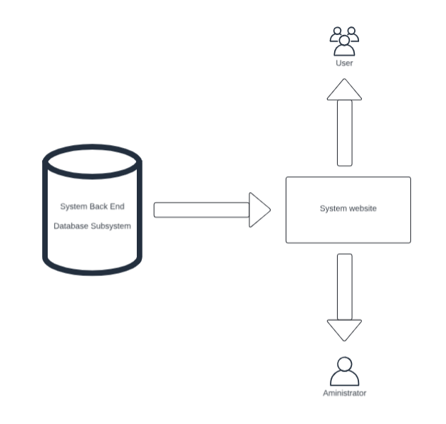

Package Diagram

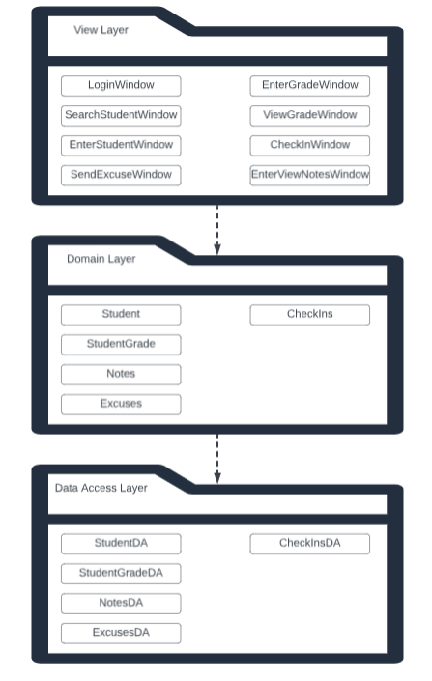

Component Diagram

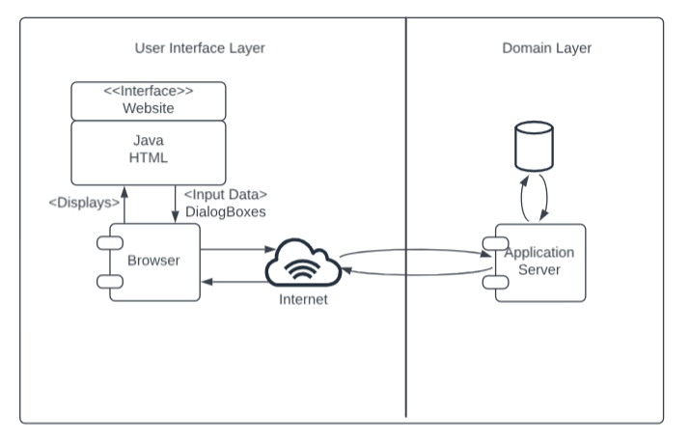

Deployment Diagram

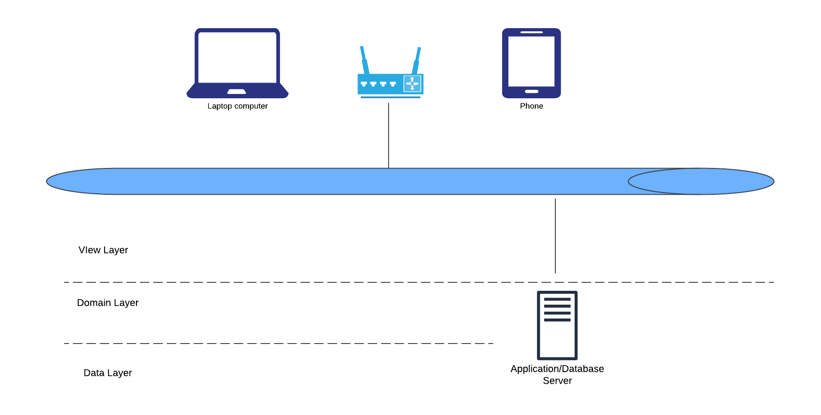

**Detailed Design**

Database design

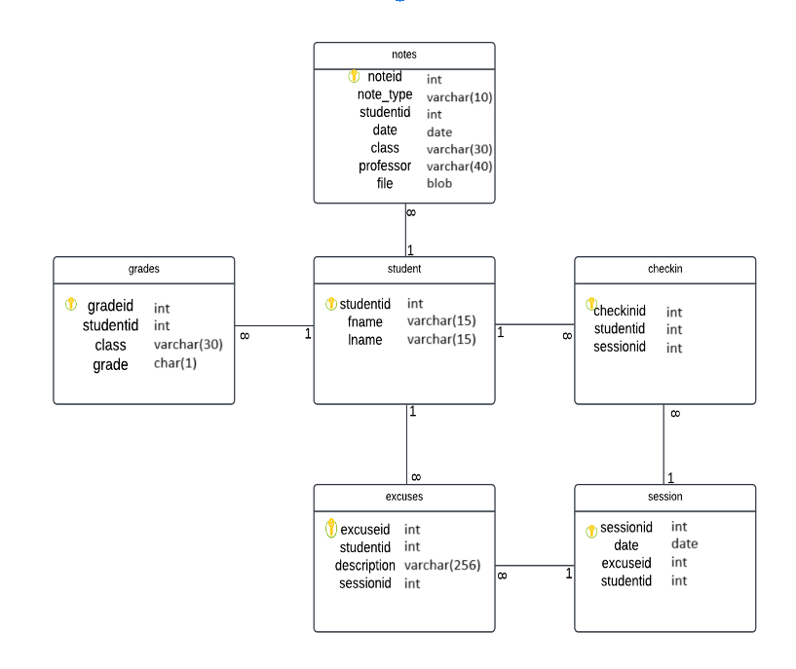

Class Diagram

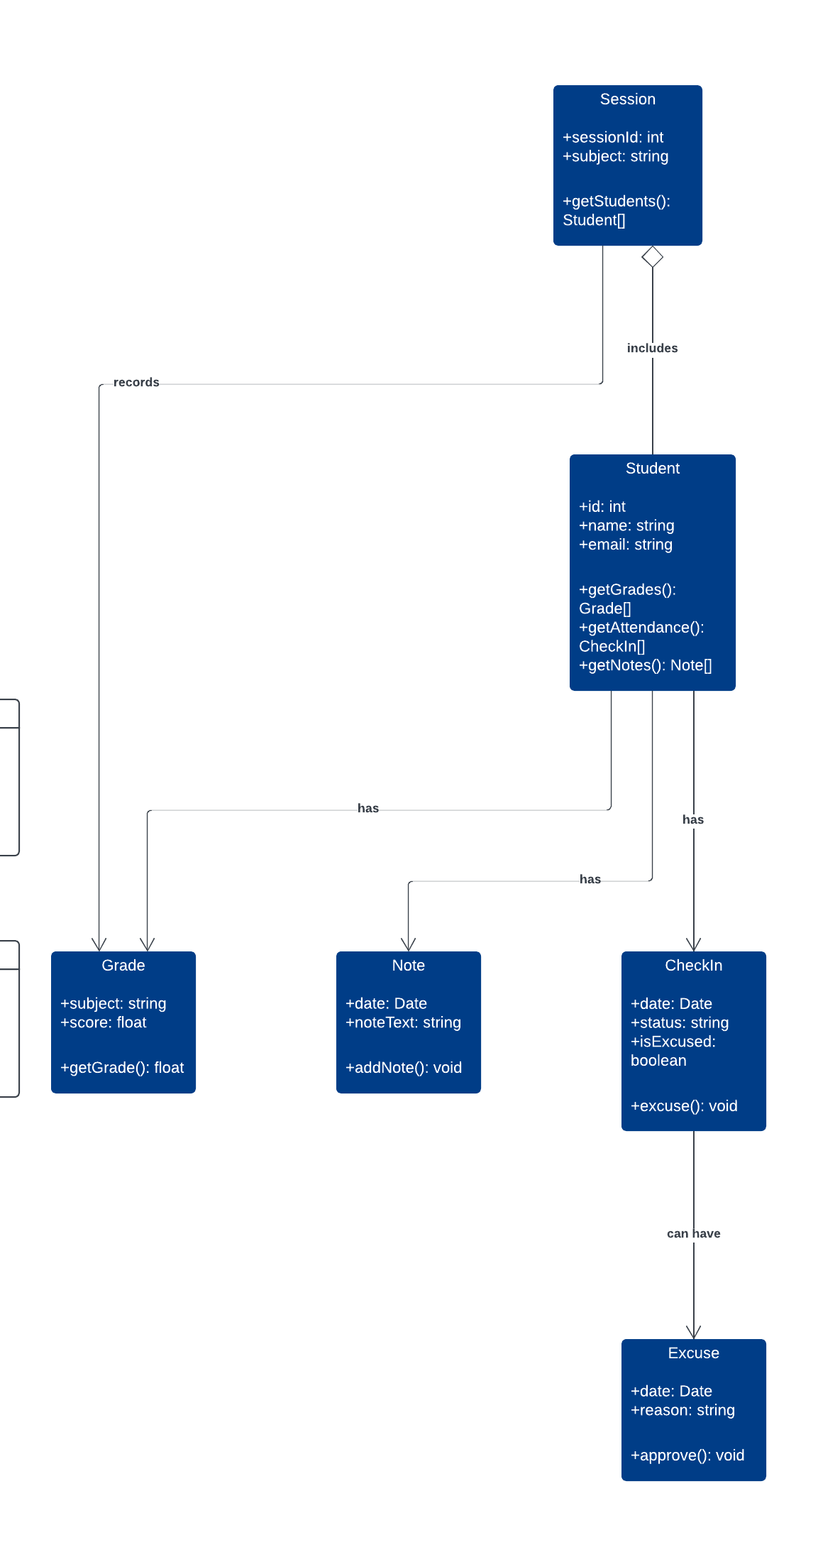

System Sequence Diagram

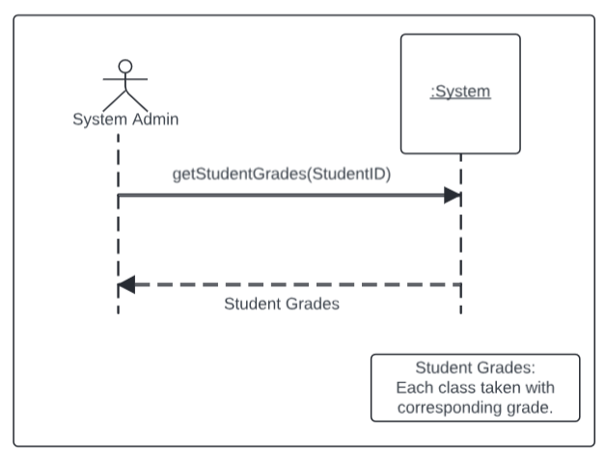

State machine diagram

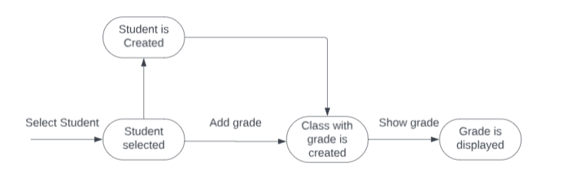

**Project Management**

Net Present Value and Payback Period

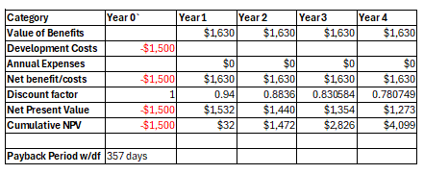

Return on Investment Calculation

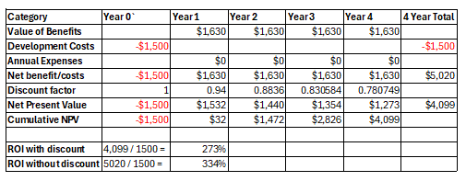

PERT Chart



CPM Chart

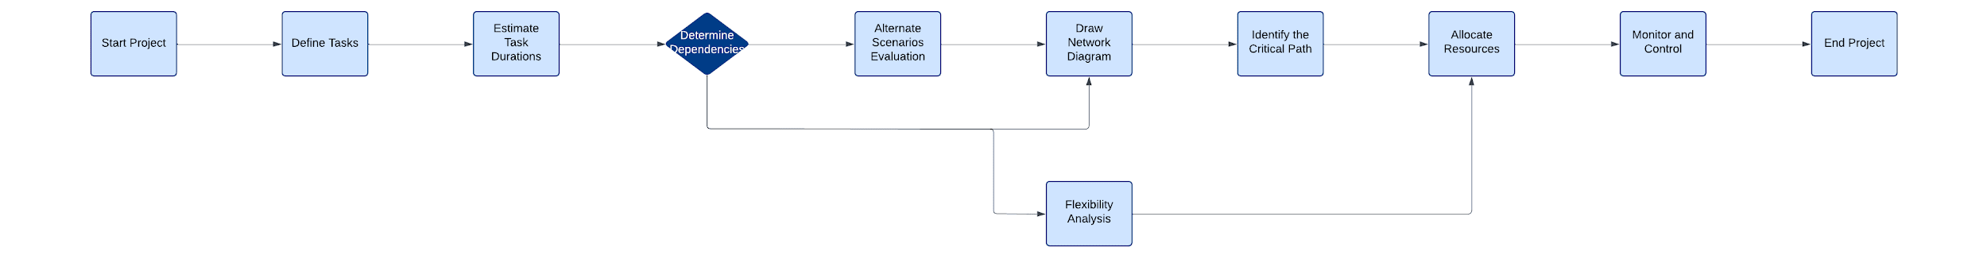

**Working Prototype or Mockup of Prototype**

Navigation Diagram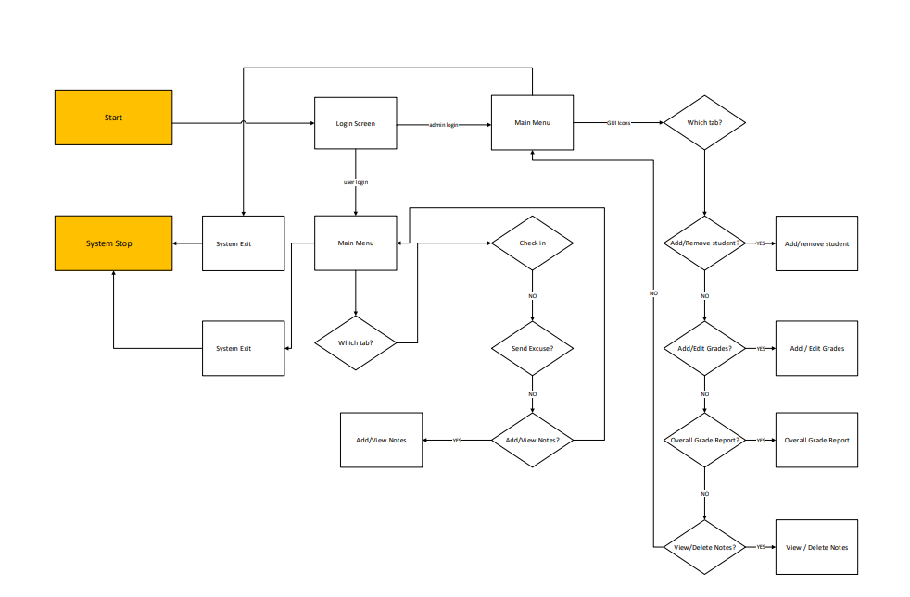

Refined Navigation Diagram

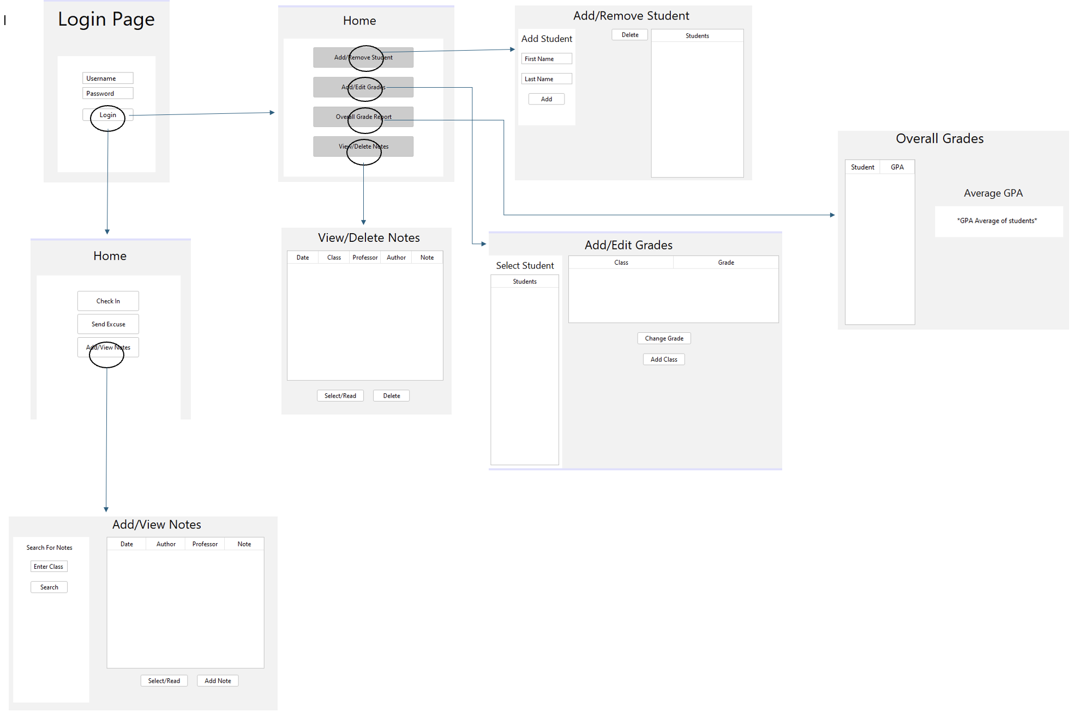

System Explanation

